|  |  |  |
| --- | --- | --- |
| **Assessment Coversheet and Feedback Form** | **Faculty of Computing, Engineering and Media**  **Leicester Media School** |  |

|  |  |  |  |
| --- | --- | --- | --- |
| **Student Name** | **Jen Kettle** | Reasonable Adjustments |  |
| **Student Number** | **P2714765** | Check this box [x] if the Faculty has notified you that you are eligible for a Reasonable Adjustment (including additional time) in relation to the marking of this assessment. Please note that action may be taken under the University’s Student Disciplinary Procedure against any student making a false claim for Reasonable Adjustments. | |
| Course and Year | Media Production Level 4 |
| Module Code | PROD1003 |
| Module Title | Introduction to Digital Design |
| Module Tutor | Thom Corah |
| Personal Tutor | Adam Wykes |

Complete the details in the **grey panels** and leave everything else blank. Where appropriate, copy and paste your submission after the first pages as indicated. You are reminded of the University regulations on cheating. Except where the assessment is group-based, the final piece of work submitted must be your own work. Close similarity between submissions is likely to lead to an investigation for cheating. You must submit a file in an MSWord or equivalent format as tutors will use MSWord to provide feedback including, where appropriate, annotations in the text.

|  |  |  |  |  |
| --- | --- | --- | --- | --- |
| **First Marker Name:** | **Thom Corah** | **Date:** |  | |
| **Feedback:** General comments on the quality of the work, its successes and where it could be improved | | | | |
| **Website Content**  **Website Style**  **Website Technical Skills**  **Production Documentation**  **Evaluation** | | | | **Provisional Uncapped Mark** Marks are capped at 40% for Late Submission or Resit Assessment and may be moderated up or down by the Assessment Board |
| % |

|  |  |  |  |  |  |
| --- | --- | --- | --- | --- | --- |
| **Quality and use of Standard English and Academic Conventions** | | | | | |
|  | Spelling Errors |  | Style is Colloquial |  | **Standard is a Cause for Concern** |
|  | Grammatical Errors |  | Inappropriate Structure | If the box above has been ticked you should arrange an appointment with a member of staff from the Centre for Learning and Study Support (CLaSS)**:** <https://libguides.library.dmu.ac.uk/class/home-v2> | |
|  | Punctuation Errors |  | Inadequate Referencing |

Marking Criteria – Please study this page carefully

|  |  |  |
| --- | --- | --- |
| Project: Criteria and Marking Scheme | | |
| 1. Website Content (15 marks) | | |
| Exemplary (70-100%) | Accomplished (50-69%) | Developing (0-49%) |
| Your website content should be fit for purpose and appropriate. This includes all text, graphics, images, sounds, and videos. You should use the correct techniques for displaying these in modern web browsers and ensure that you are using disk space and bandwidth efficiently.   * Text content shows semantic structure e.g. headings, lists * Careful selection, creation and editing of video and/or audio * Awareness of loading speed and disk space e.g. no huge images * Original content is credited and third-party content is referenced * All images have appropriate alt attributes * All audio and video content is included using the native HTML elements, with at least two formats provided, and a fall back for browsers that don't support the element. | Your website content is mostly fit for purpose and appropriate. This includes all text, graphics, images, sounds, and videos. You have attempted to use the correct techniques for displaying these in modern web browsers , although there are some issues here.   * Some use of semantic elements for displaying text content. * Awareness of loading speed and disk space e.g. few huge images * Third-party content is mostly referenced * Some images have appropriate alt attributes * Most audio and video content is included using the native HTML elements. | There is little or no attempt at ensuring that content is fit for purpose.   * Little or no use of semantic elements for displaying text content. * A lack of awareness of loading speed and disk space e.g. huge images * Third-party content is not referenced * Images are missing appropriate alt attributes * Audio and video content has not been included correctly using the native HTML elements. |
| 2. Website Style (15 marks) | | |
| Your website should demonstrate an effort to appeal to your intended audience and be consistent with your designs. You should make appropriate use of CSS in order to properly style and layout your site.   * Coherent overall design, colour and font choices * Consistent design between pages * Design and content relevant for the target audience * Skillful use of CSS to style and arrange site elements * CSS is in a single separate style sheet | Your website should demonstrate some effort to appeal to your intended audience and be mostly consistent with your designs. You should attempt to make appropriate use of CSS in order to style and layout your site.   * Some consistency between pages * Design and content appeals somewhat to the target audience * A good attempt to use CSS to style and arrange site elements * CSS is in a single separate style sheet | Your demonstrates little or no effort to appeal to your intended audience and is inconsistent with your designs. There is little attempt to make appropriate use of CSS in order to style and layout your site.   * Little or no consistency between pages * Design and content has been developed without regard for target audience. * Little or no attempt to use CSS to style and arrange site elements * CSS is sporadic and inline |
| 3. Website Technical Skills (30 marks) | | |
| Your web site contains a variety of appropriate techniques that demonstrate your ability to apply the concepts you have learnt in this part of the module.   * Evidence of intelligent ability to choose and code current website techniques * All links work, media loads, site is consistent across browsers * Demonstration of more advanced skills such as CSS animations and transitions or appropriate use of JavaScript. | Your web site contains some appropriate techniques that demonstrate your ability to apply the concepts you have learnt in this part of the module.   * Some evidence of intelligent ability to choose and code current website techniques * Most links work and media loads. * Demonstration of core skills such as CSS for layout and style | Your web site contains few appropriate techniques to demonstrate your ability to apply the concepts you have learnt in this part of the module.   * Little or no evidence of intelligent ability to choose and code current website techniques * The site features broken links, or media that doesn’t load. * Little demonstration of core skills such as CSS for layout and style |
| 4. Production Documentation (15 marks) | | |
| You have included thorough code commenting to annotate your code.  This gives a high degree of insight into the development of your website. Your comments document what your code does and why at every point. It would be useful to include any discussion of alternative approaches as appropriate. For example, if you considered a different style of menu, why have you gone with what you've got.  Your comments clearly show where you have used code from elsewhere, including a link to the source of the code. As well as for directly copied code, this also applies to code that has resulted from you following a tutorial. | You have included some code commenting to annotate your code.  This gives a good degree of insight into the development of your website. Your comments document what most of your code does and why.  Your comments clearly show where you have used code from elsewhere, including a link to the source of the code. As well as for directly copied code, this also applies to code that has resulted from you following a tutorial. | You have included little or no code commenting to annotate your code.  This gives little or no insight into the development of your website.  Your comments demonstrate little or no understanding of what your code does.  You have not used comments to clearly identify the source of third-party code or code resulting from an online tutorial. |
| 5. Evaluation (25 marks) | | |
| You provide a clear evaluation document, that is clearly written and presented.  You have addressed the following points:   * Provide evidence of testing (e.g. all links work, media loads, the site is consistent across browsers). * Provide evidence and a breakdown of structured user testing and feedback. * Evaluate your work, with reference to testing where appropriate, and user feedback, describing: _ Your achievements, refer back to the original aims, explain any changes to your original ideas and why or how they have happened. _ Any limitations of your web site _ Any improvements you would make to the site and why _ Any problems you encountered along the way, with potential solutions where possible. | You provide an evaluation document, that is fairly well written and presented. There are some issues with grammar and layout.  You have addressed some of the following points:   * Provide evidence of testing (e.g. all links work, media loads, the site is consistent across browsers). * Provide evidence and a breakdown of structured user testing and feedback. * Evaluate your work, with reference to testing where appropriate, and user feedback, describing: _ Your achievements, refer back to the original aims, explain any changes to your original ideas and why or how they have happened. _ Any limitations of your web site _ Any improvements you would make to the site and why _ Any problems you encountered along the way, with potential solutions where possible. | There is no evaluation provided, or if there is it is insubstantial or vague.  There is little or no evidence of testing, and any conclusions stated are vague and shallow. |

# Introduction

I decided that my programmed two-page website would be of my own photographs taken in my spare time, as a re-creation of the personal photography portfolio concept which I made in the previous half of this module, Interface Design, in order to make this site design come true. I’d put the design together as an improved version of how the portfolio website of photographer Tom Hull was designed, so I saw the chance to make my own photography web pages a reality somewhat as going the extra mile in this improvement upon an original inspiration source.

# Testing

Once the gradual ongoing development of my site’s programming had reached the stage where I now had a functioning Beta version as an unfinished prototype, I took the opportunity to create a user feedback survey which I then sent out to various people I know, such as but not limited to my parents and the members of my friendship circle. In the end, I gained a total of thirteen answers from said other people, with the results shown below from Questions 2 to 5 seeming to be a predominantly positive response to this Beta version of my website.

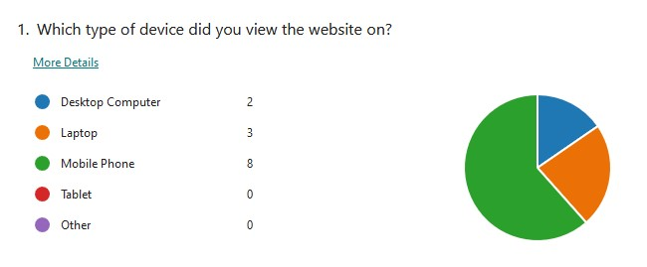

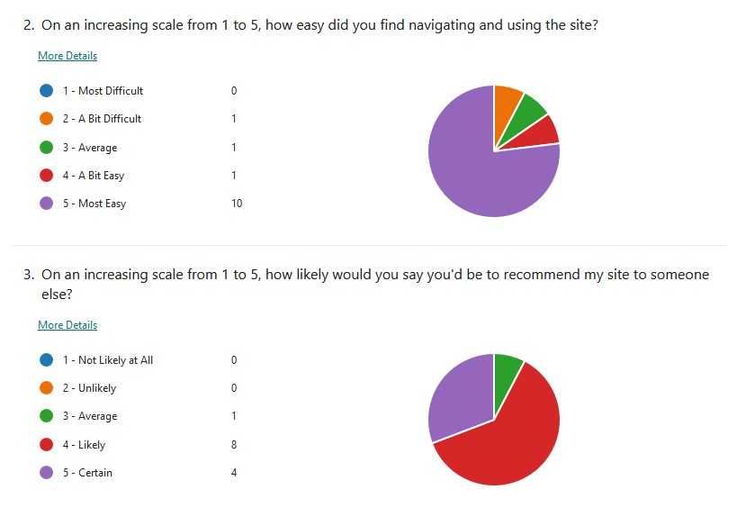

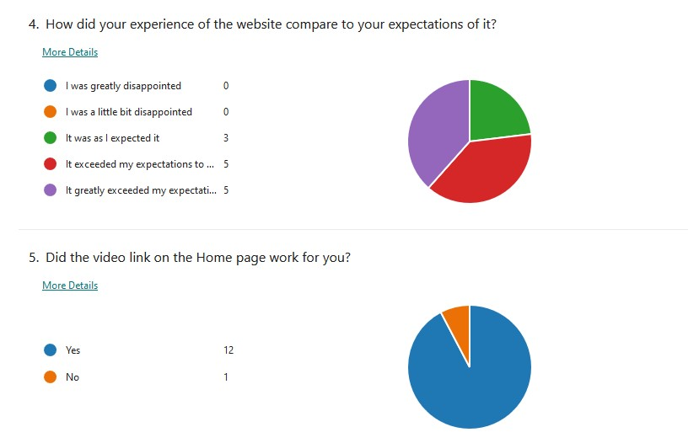

The one outlying answer from all twelve of the others, the sole ‘No’ in Question 5 to whether or not my video link worked for them, took me by surprise and struck me as an unusual result. However, the most-chosen answer to the first question for which device was used to view my site, Mobile Phones, served to put my mind at ease regarding the look of the site’s text and image arrangement; before seeing in the responses to the sixth and final question how positive the overall reception of my website was, I initially had some worries over how different the elements’ arrangements around each other would look on other devices apart from a PC, which is the particular device that I used to developed the coding on.

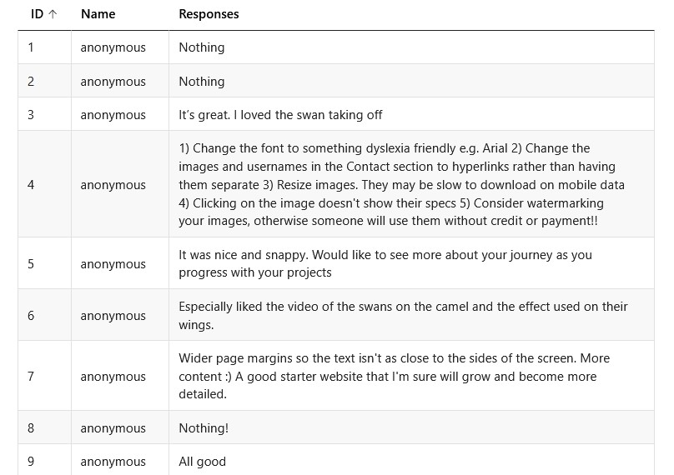

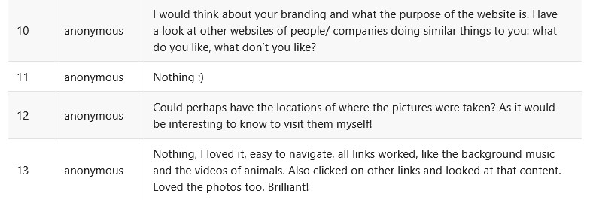

Answers 4.4 and 12 in particular for the sixth and final question of the survey encouraged me to proceed with implementing one last feature that I’d already planned for the site’s final version after gaining these responses for the Beta: the locations and technical camera settings for each of the photographs when they were taken being displayed as text elements over the tops of the images. I went about this by programming these details and their dark grey overlay background to be shown if and when the eight photos are hovered over with the mouse cursor – initially, I’d planned on it being a JavaScript event that occurs when they’re instead actually clicked on, though I believe this slight change has been successful in creating more of a feel of unity on the Portfolio page, as this way the user doesn’t need to carry out an action which may give off the impression that the overlays are separate elements.

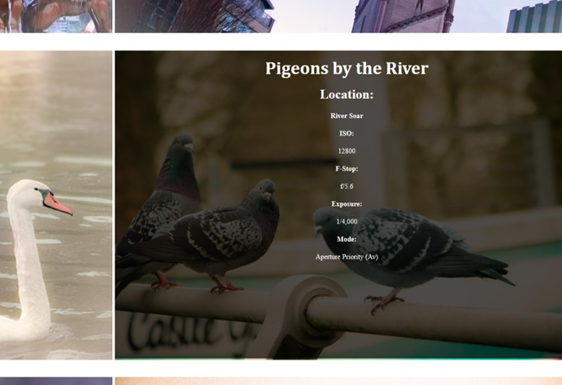

*The overlay feature that’s programmed to show the technical specifications and the location of each of the eight photographs, demonstrated on one of these photos*

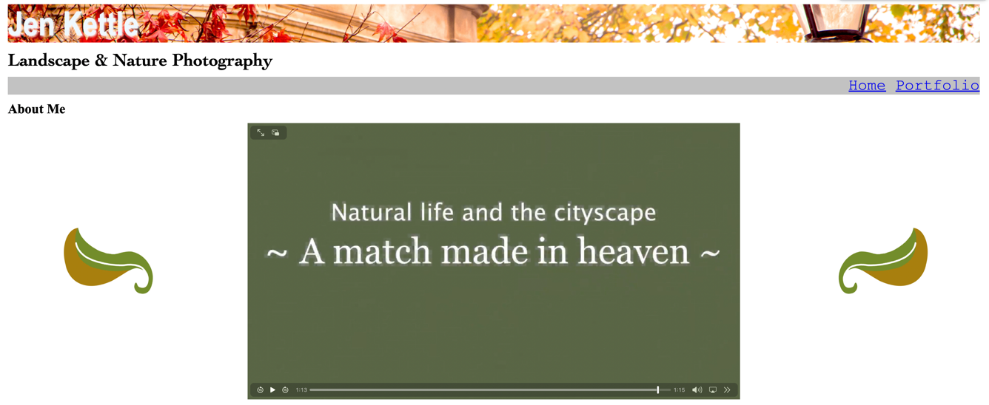

*My edited nature video from a group exercise for a module several months ago, in use on the Home page where it’s situated as the first content element that the user will see upon opening my site*

Furthermore, answers 3, 6 and 13 to this same final question seem to be indicating a positive response to the video link displayed on the Home page, which, like the details shown as Overlays for the photographs on Portfolio, is another programmed element of my site which has the ability to be interacted with to an extent by the users. Meanwhile, I was informed both in-person and via answer number 7, both being from two different people, that wider margins for the content and layout of both of the pages would be a desirable change to also implement after this Beta testing, for extra neatness, and so I then did just that for what’s now the final version of my website through my code’s CSS file, all at fifteen pixels in size.

I additionally garnered face to face feedback in person and over text by two of the people who answered the survey, telling me that the section I’d included at the bottoms of both pages as a footer, containing the means of contacting me such as links to my social media accounts, included too much of my personal information and would therefore put me at risk. Specifically, I’d included my postal address and my phone number, because of the fact that I’d decided at the offset that the site would be predicated on my design concept from the previous module half, and so I decided to remove both of these due to this response. And as a result of answer number 4.2, recommending that I alter the images and account names for my social media platforms to hyperlinks, I removed the text showing the account names altogether, leaving only the links themselves beneath the platform titles which I added ‘target=”_blank”’ to in order for them to lead to user to separate tabs from the site.

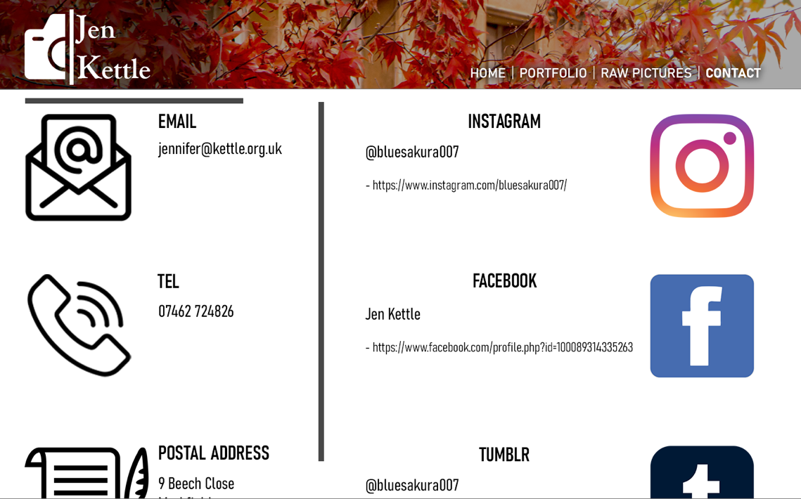

*The very first conceptualised design idea for the contact footer area of the website, from the first half of the module that my programmed site was based on*

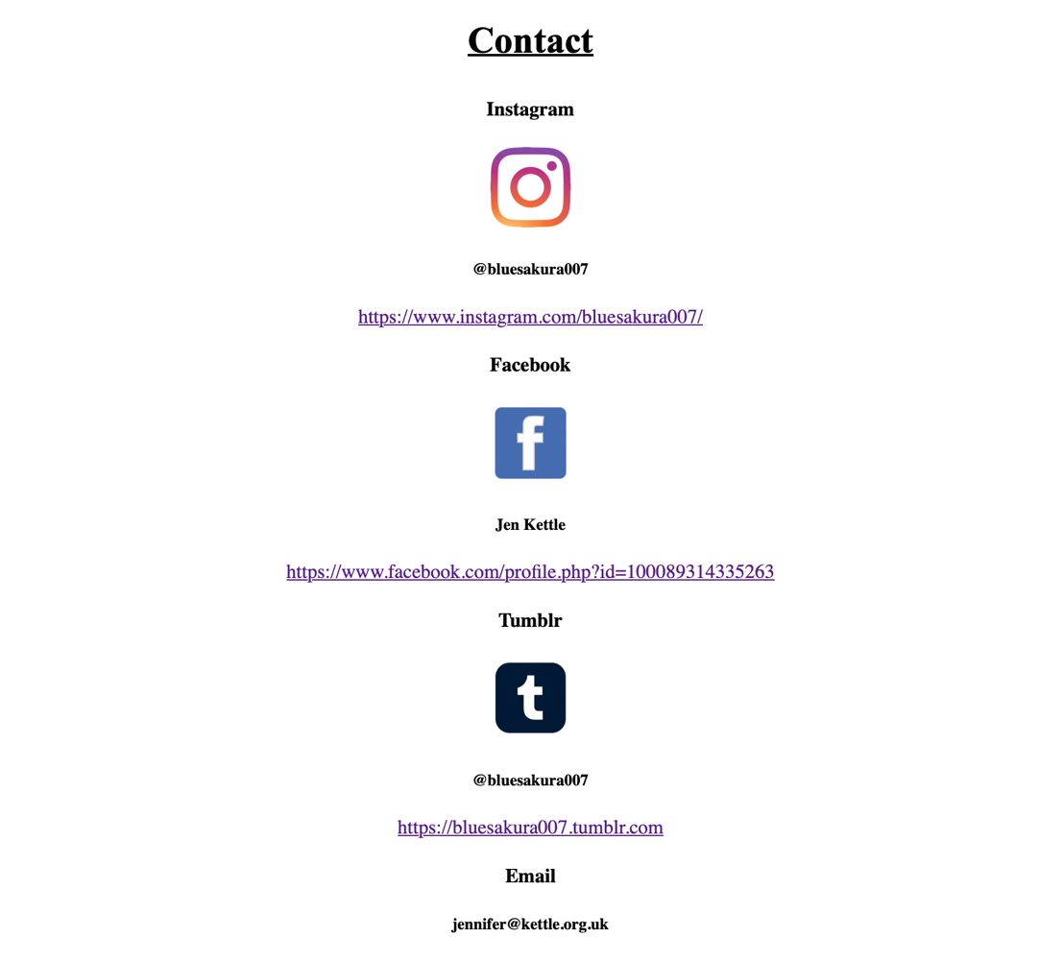

*After the Beta testing, this was what the contact footer then looked like following the suggested changes that I made*

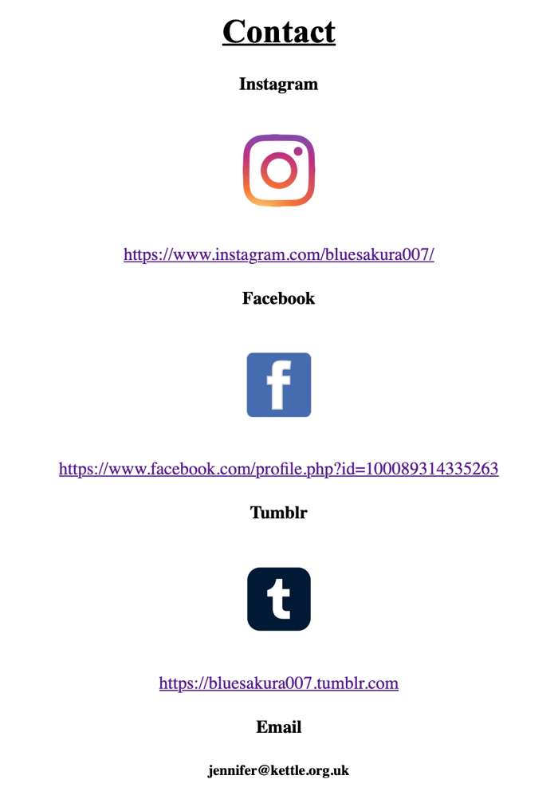

*What this same section looks like now, as a part of the finished version of the site*

# Evaluation

It’s my belief that on the whole, the end result of my programmed website was a success, albeit with some room for further improvement; the most notable example is likely to be the overlay transitions for displaying the photographs’ details. This is because on PCs, their text pieces are shown perfectly fine whereas on mobile some of these pieces at the bottom got cut off and didn’t show up at all, but it could very well be something that I’ll aim to improve in future by considering this when writing out the first, fundamental parts of the HTML coding.

Another element that I think could have also been better on the site was my avatar image on the Home page, as it ultimately became much smaller than I ideally wanted it to be so that its float code wouldn’t interfere with the contact footer area. However, based on the feedback I received it seems like my Beta test users didn’t notice or mind about this. Overall, although HTML and CSS programming is something I’m not that well-suited for and parts of the process thus proved to be quite difficult, I’m quite happy with how my site’s turned out, and I believe that this could potentially open the door to making more advanced and professional-looking sites in future.

# Social Media Icons References

Freepngimg.com. (2023). Available at: <https://www.freepngimg.com/download/logo/69823-instagram-icons-symbol-youtube-computer-logo.png>.

Webstockreview.net. (2023). Available at: <https://webstockreview.net/images/facebook-clipart-app-4.png>.

yusufonaldi.com (n.d.). *Free Tumblr Logo Icon*. [online] www.iconpacks.net. Available at: <https://www.iconpacks.net/free-icon/tumblr-logo-2434.html>.